The preprocessing procedure consists of several steps:

1. Extract noise induced by fish’s motion artifact or gear, creating several segments with different length.

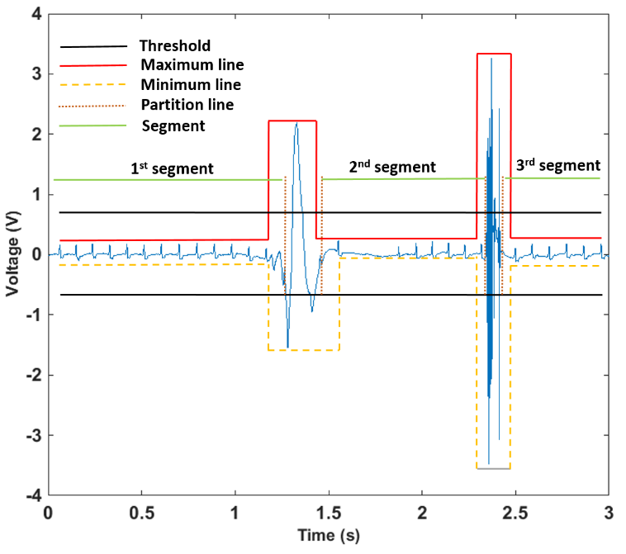

1. Partition segments in first step into sub-segments with length of 4096 to apply Wavelet method. Doing this because the noise level is not conformal for every piece of signal and partitioning into sub-segments with the length of 4096 will optimize adaptive Wavelet’s capabilities of de-nosing.
2. Combine filtered sub-segments together.

**Code structure:**

1. Main file: **TrimOffandWT.m** including sub-functions of **extractNoise.m** and **preprocessingWT.m**. To run program, run main file **TrimOffandWT.m**
2. **extractNoise.m** file’s output is segments without noises induced by fish’s motion artifact such as gear movement
3. **preprocessingWT.m** file contains sub-functions including **partitionData**.m and **combineData**.m and other one for WT method. It also contains the piece of code for saving filtered data to new folder.

**Notice:**

1. This code is capable of processing dataset containing many signals with only one execution. The signal ‘s name in the dataset should be formatted conformally.

For example:

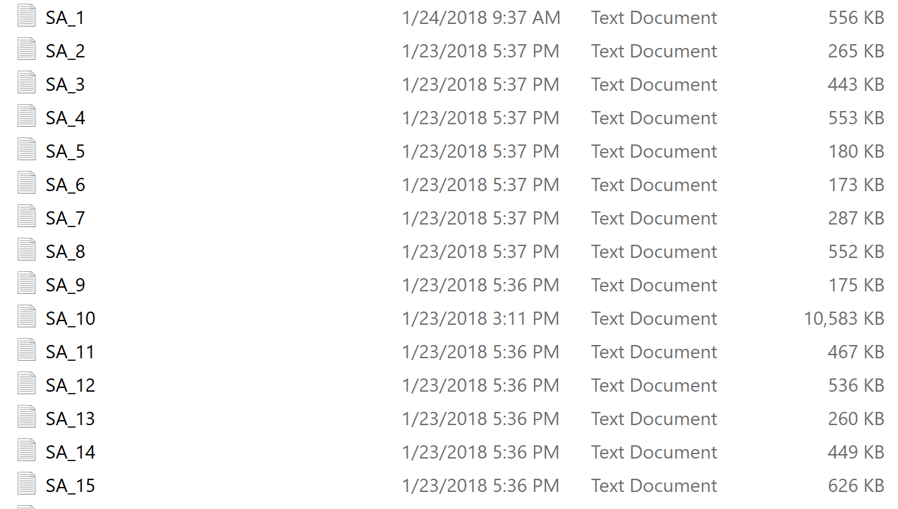

1. For setting up input file: Make sure you import correct the repository of folder containing dataset.

For example:

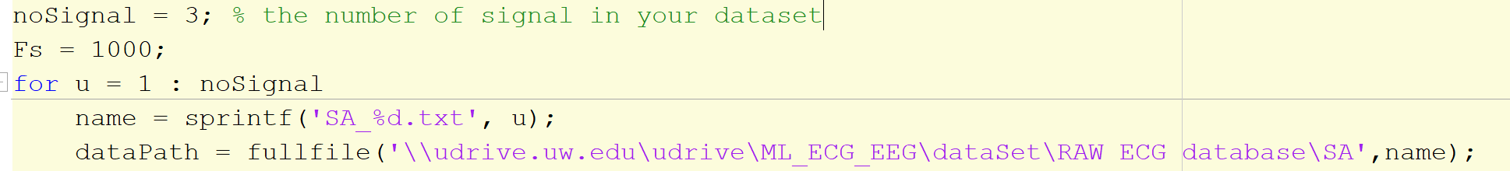

1. For saving the filtered data, I created a folder named processedData so that all the filtere data will be stored in this folder.